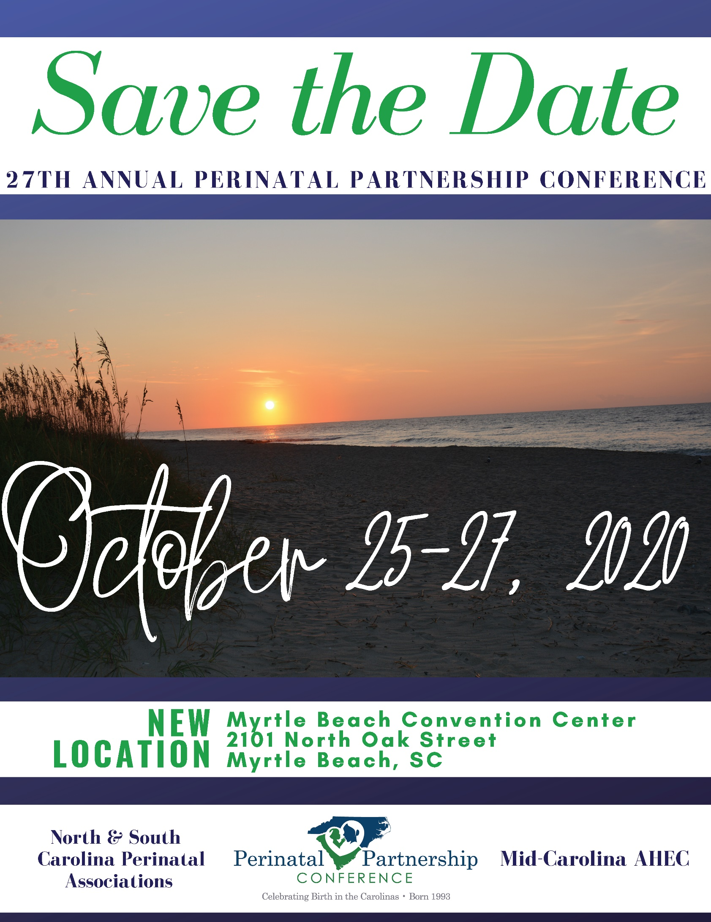
The 2020 Conference Planning Committee is seeking poster abstract submissions.
The focus for abstracts is three broad categories:
- Innovative Clinical Practice
- Models that Work: Service and Education
- Applied Research

Abstract Submission Requirements: Deadline for Submission: August 14, 2020 Submission Requirements:
- Abstracts should be double-spaced on one page as a Microsoft Word Attachment
- Please complete the attached abstract submission form and send along with your abstract.
- Please send one copy of abstract with information identifying authors and institution, and one copy of the abstract without identifying information.

Please submit materials to:

Mona Brown Ketner
Email: mketner@wakehealth.edu Phone: 336-713-7730

Registration requirements:
- The individual(s) designated for the poster presentation must register for the conference.
- One individual selected per poster presentation will receive a $50 conference discount.
- Abstracts will be voted upon by conference participants. The winner will receive one free conference registration for the 2021 NC/SC Perinatal Conference at Concord, NC.
- Abstracts will be reviewed by a committee. If selected, a confirmation letter and registration instructions will be emailed by September 3, 2020 to the submitting author unless otherwise indicated.

Thank you for taking the time to consider actively participating in our meeting.
We look forward to seeing you in Myrtle Beach, SC!

Abstract Submission Form

Title of Abstract:
Abstract Submitted by:
Name:
Email Address:
Phone Number:
Fax Number
Agency Name:
Mailing Address:
Co-Author(s) with email
address:

For Abstract Committee:
ID Number: ____
Review Score: ____
Date Received: ____
Accepted for Poster presentation: _Yes _No

